GREYSTOKE SURGERY Summer 2024

# Greystoke Gazette

Welcome to our new edition of the Greystoke Gazette. We will be creating a new newsletter twice a year to keep up to date with exciting Practice developments.

We have seen a lot of change in the last year, with some of our colleagues moving into different roles and welcoming new staff into our team. We have heavily invested in a number of areas, including patient access, staff recruitment and retainment, staff training courses, new equipment and team wellbeing.

In May 2023 we took the step to implement the Accurx triage system. This has been a great success and patient feedback has been very encouraging. Please see the results at the end of this newsletter. Such triage systems are likely to be adopted across the UK to help GP access and we are early pioneers. The added benefit, for those that are unable to access IT, is that the online triage system frees up the phones, allowing better access to our reception staff by telephone for those in need. The aim of patient triage is to get your query directed to the most appropriate person to help the problem in a timely manner.

In coming months, we are also looking to produce a new website and work on this is underway. The hope would be to make the information you need easily accessible. We have recently had staff photos taken and these will be displayed in reception and on the website, to familiarise you with the Greystoke Team. Another positive change will be a move towards a cloud telephony system that will have many patient benefits. We will keep you posted….

## **STAFF UPDATES**

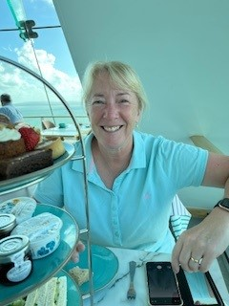**DR THOMPSON HAS RETIRED!**

The time has come to hang up my stethoscope and retire. I have been very lucky and privileged to work at Greystoke Surgery for 24 years and in Morpeth for 30 years, which means I will miss everyone so much. I have seen a lot of changes, including moving from a fantastic Victorian House as the 'Old' Greystoke to the modern premises we are now in with all of it's services for us to use. I have loved being a GP and hopefully have helped make a difference for some of you during my career, but now it is time for me to do all of those things I have been wanting to take part in over the years. You might see me out on my bike more or possibly on the Golf course if I can somehow manage to get the clubs to connect with the ball.

I know you are being left in very capable hands and I wish every single one (both patients and staff) the very best for the future!

**NEW FACES….**

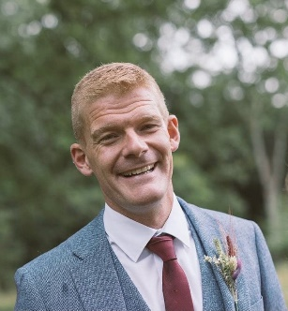**DR JAMIE WILLEY (NEW PARTNER)**

I grew up and trained in Northumberland, Greystoke being one of my GP training practices. I have since worked in a number surgeries locally before moving back to Greystoke in 2024.

I enjoy all aspects of General Practice but have some special interest training in drug and alcohol misuse as well as an interest in Learning Disability and safeguarding. I am really looking forward to starting at Greystoke as a Partner in late August 2024.

In my spare time I have a passion for music. I like to keep fit and get out for walks with my wife and my dog in the Northumberland countryside.

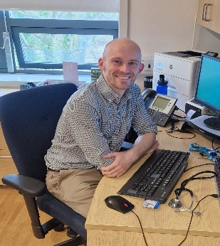**DR MATTHEW KEIR (Salaried GP)**

I returned to Greystoke as a salaried GP after having previously worked at the practice as a trainee. I enjoy the variety that general practice offers, and the opportunity to get to know patients over time, but particularly enjoy seeing patients with acute health issues. I also work with the team at Newcastle University teaching medical students.



**TRAINEES**

We continue our dedication to training doctors in General Practice and have 2 new doctors joining us from August 2024 for a year. After medical school and hospital training, doctors then spend 3 years on a dedicated GP training programme.

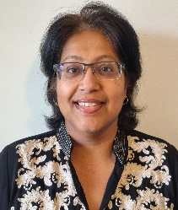**DR ESTHER PAUL (GP Doctor in Training, ST2)**

I did my training in India and have worked both there and in Saudi Arabia. I spent time as a microbiologist and also worked at the medical school. I am particularly interested in paediatrics and dermatology. My hobbies are reading and listening to soft rock music.

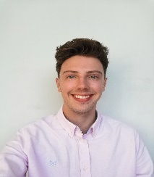**DR ADAM VAUGHAN (GP DOCTOR in Training, ST3)**

I graduated from Newcastle University in 2020 and started work early to help out with COVID pressures at North Tees Hospital in Stockton. I then came back to Northumberland to start my hospital training at NSECH, North Tyneside and Wansbeck Hospitals. I stayed in the region for GP training and worked in Sunderland before coming to Greystoke Surgery for my final year of training. I love getting to know my patients and the variety general practice brings. My clinical interests include dermatology and skin cancer, aesthetics and minor surgery, and mental health. I also enjoy mentoring students and more junior colleagues.

Outside of work, you'll catch me in my garden attempting to grow something or spending too much time looking after my lawn. Being from Yorkshire, I've always got my eye out for a bargain, and I can't resist a good deal, so my weekends are often filled with random trips and activities.



|  |
| --- |
| THE NEXT  GENERATION  Dr Lyall has  welcomed a baby boy! Dr Howson will be covering her absence. |

Do you have the NHS App? If not download it today to get access to your medical record, results, prescriptions and patient triage form. Any queries please contact reception.

TEXT MESSAGING

Do we have your consent to receive updates from the practice? If not, please contact reception. Please remember to always update your telephone number if you get a new one!

**PROFESSIONAL DEVELOPMENT**

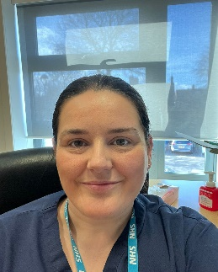KAYLEIGH ANGUS, ADVANCED NURSE PRACTITIONER—Kayleigh is currently doing a Masters in Advanced Clinical Practice at Cumbria University. Once this is complete she will be an Advanced Clinician Practitioner enabling her skills to see and treat a wider population of patients. She already has a wide scope of independent practice. The course is 3 years long, and she is coming towards the end of her 1st year. Whilst studying she continues to work as an Advanced Nurse Practitioner, working Tuesdays, Thursdays and Friday, Mondays are allocated to study time and supervision.

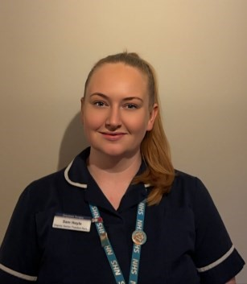SAMANTHA HOYLE, PRACTICE NURSE—Sam has commenced the v300 module which equips her with the required knowledge, skills, competencies and attitudes to safely and effectively assess, prescribe and review medications as an independent and supplementary prescriber. This module will help improve patients’ access to medicines and in doing so will help reduce waiting times and delays. This should lead to greater service efficiency and better patient experience.

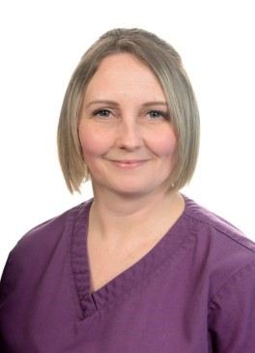KATE STEPHENSON, HCA - Kate is currently doing a foundation degree in nursing associate practice in the apprenticeship route with the open university. The course is over 2 years with 4 placements over that time frame. At the end she will be a registered nursing associate which will give her a registration on the NMC and more opportunity to take on extra responsibilities and develop her skills within the Practice.

**PPG (PATIENT PARTICIPATION GROUP)**

We are always looking for new Patient Participation Group (PPG) members. The PPG meet online every two months to discuss updates affecting the practice and to provide a patient voice. If you could give up a small amount of time to contribute to our group, please contact our Practice Managers.

**NATIONAL GP PATIENT SURVEY RESULTS – Full results available at** [**https://gp-patient.co.uk/**](https://gp-patient.co.uk/)

